Based on prior research we decided that Stripe would the most suitable payment platform for Trippie. Stripe offers a feature called “Stripe Connect” that provides many different tools and a powerful API that would be needed to accept payments and pay Tripsters (Trippie service providers).

Using Stripe Connect requires us the platform (Trippie) to create a connected account for every user that will be receiving money on Trippie (Tripsters). These connected accounts are divided into three different types. Therefore, selecting the right method of managing the connected accounts is very important. The account types we can use with Stripe Connect are listed below each being suitable for different use cases:

* Standard
* Express
* Custom

## Creating Charges

However, in order to understand what each account type is designed for and what would be the best option for us, we also need to understand what the best approach to creating charges on behalf of our connected accounts would be. The table below from Stripe highlights the different cases that each charging approach is designed for.

|  |  |  |
| --- | --- | --- |
|  | USE WHEN | EXAMPLES |
| Direct charges | * End customers directly transact with the connected account, often unaware of the platform's existence * A single connected account is involved in the transaction | * An e-commerce platform like Shopify or Squarespace * An accounting platform that enables invoice payments like Freshbooks |
| Destination charges | * End customers transact with the platform for products or services provided by the connected account * A single connected account is involved in the transaction | * A ridesharing service like Lyft * A services platform like Thumbtack |
| Separate charges and transfers | * Multiple connected accounts are involved in the transaction, or * Specific connected account isn't known at the time of charge, or * Transfer cannot be made at time of charge | * An e-commerce marketplace that allows a single shopping cart for goods sold by multiple businesses * A scooter-sharing platform like Bird, where scooters are booked when platform customers want them, and people are paid to charge the scooters' batteries at a different time |

### Direct charges

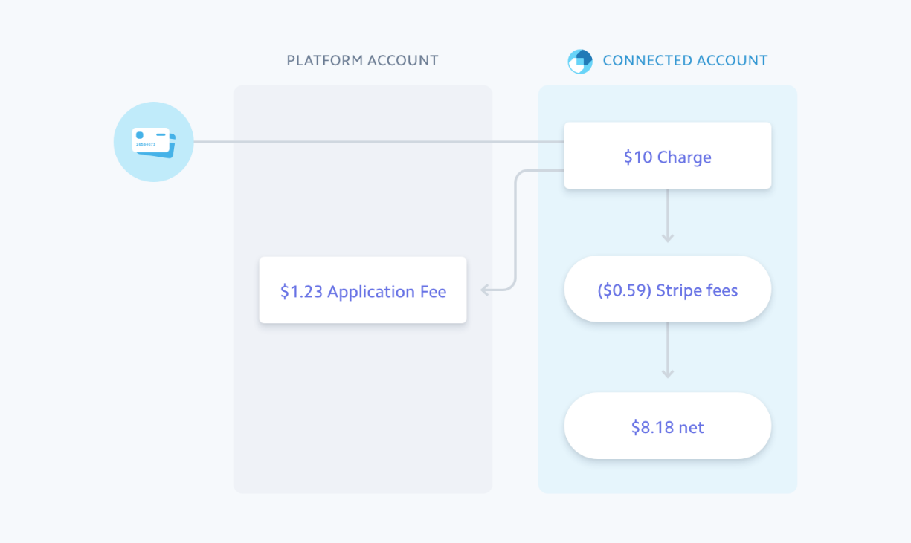Stripe recommends using this approach when using standard accounts to manage our Tripsters’ connected accounts. With direct charges, the connected account is responsible for the Stripe fees, refunds and chargebacks. Direct charged are reported only on the connected account and not our platform’s (Trippie) dashboard or other reports. We as the platform can only collect money from the payment by specifying an application fee. The image below shows the flow of funds when making direct charges.

(Stripe, Creating direct charges)

### Destination charges

Stripe recommends using this approach when using Express and Custom accounts. With this approach, Trippie would be responsible for the cost of Stripe fees, refunds and chargebacks. Using destination charges, provides different options for how the funds move:

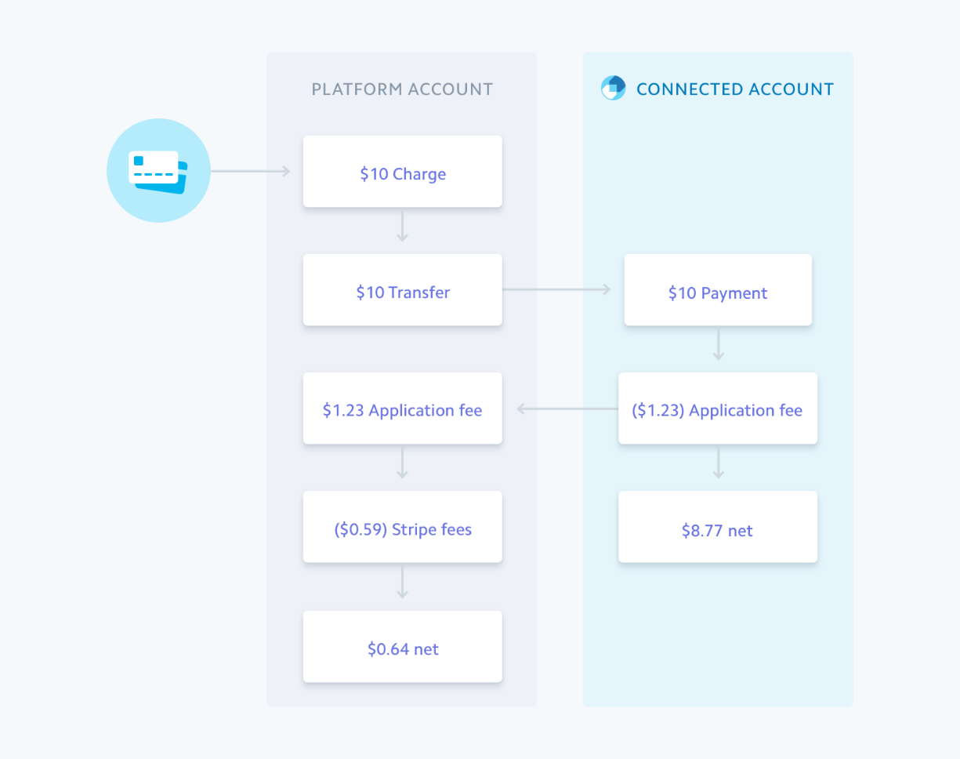

(Stripe, Creating destination charges on your platform)

(Stripe, Creating destination charges on your platform)

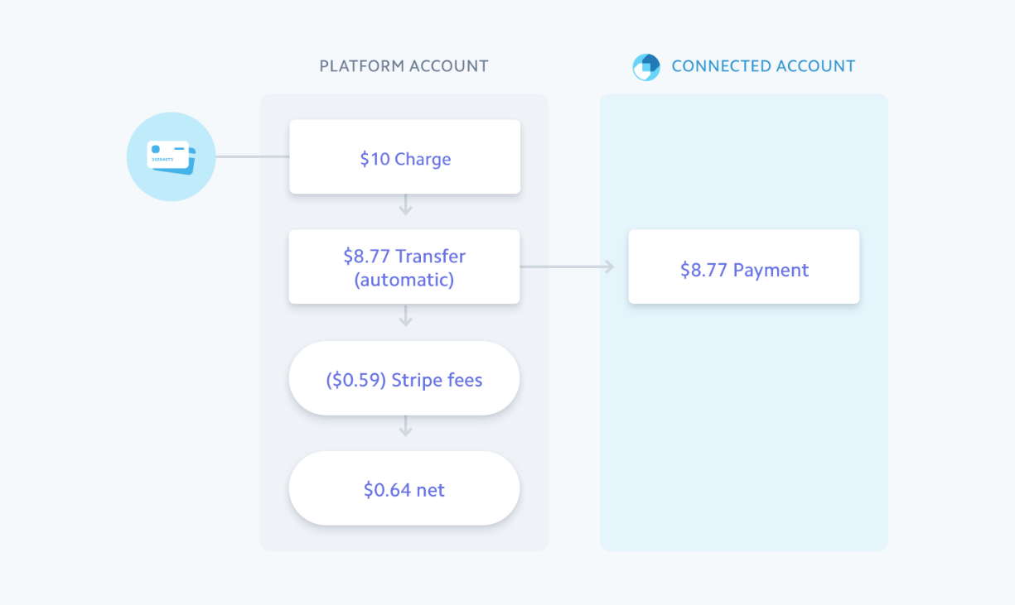

### Separate charges and transfers

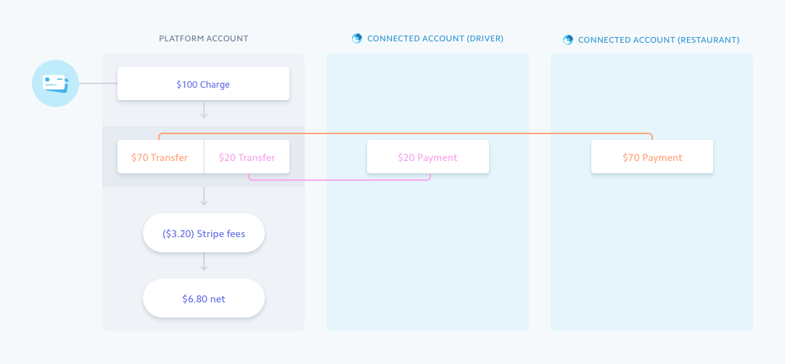This approach is recommended for Custom or Express accounts where the amount you collect is different from what is paid out to your connected account. You as the platform are responsible for the Stripe fees, chargebacks and refunds. Also, this approach is only supported when the connected account and your platform are in the same region. The figure below is an example of how the funds are transferred when using this approach.

(Stripe, Creating separate charges and transfers)

## Connected Account Types

According to the stripe documentation, below is a list of scenarios for which each account is most suitable for:

|  |  |  |  |
| --- | --- | --- | --- |
|  | STANDARD | EXPRESS | CUSTOM |
| Integration Effort | Lowest | Low | Significantly higher |
| Fraud and dispute liability | User (Only when using direct charges) | Platform | Platform |
| Onboarding and Identity information gathering | Stripe | Stripe | Platform or Stripe |
| Support new countries without integration changes | Yes | Yes | No |
| Ideal for | Experienced online businesses | Any type | Able to dedicate significant engineering resources |

(Stripe, Connect account types)

### Standard

A standard account is basically a general stripe account. This means that the user of the standard account can log in to Stripe to access their dashboard and can process charges on their own.

One key thing to note is that with standard accounts, the platform (Trippie) is responsible for fraud and disputes when using destination charges, but when using direct charges, the user (owner of the connected account) is responsible.

When to use standard accounts:

* Want to get started quickly and don’t need a lot of control over your user’s experience.
* Have users that are familiar with running online businesses or might already have a Stripe account.
* Want to use direct charges
* Prefer that Stripe handles communication for account issues directly with the user (e.g., to request more information for identity verification purposes). (Stripe, Using Connect with Standard accounts)

### Express

With Express accounts, the platform can specify the flow of funds and is responsible for handling disputes and frauds. This is similar to a custom account, but Stripe handles the onboarding and identity verification for express accounts.

With Express accounts, Tripsters will have access to a minimal Stripe Dashboard that will allow them to manage their personal information. Tripsters will also mostly be dealing with Trippie in terms of the payment processing but they do have some interactions with Stripe.

Express is suitable for when you:

* Want to get started quickly (letting Stripe handle account onboarding, management, and identity verification)
* Want to use destination charges
* Want significant control over your user’s experience (Stripe, Using Connect with Express accounts)

### Custom Accounts

A custom Stripe account is like a ghost account. This means that the Stripe account is totally invisible to the user (in our case a Tripster). With this approach, Stripe has no connection with the account holders and therefore Trippie would be responsible for all interaction including collecting and updating all the information that Stripe would need.

* Want complete control over your user’s experience
* Can build the significant infrastructure required to collect user information, create a user dashboard, and handle support
* Want to handle all communication with your users, rather than having your users contact Stripe directly (Stripe, Using Connect with Custom accounts)

## Conclusion

In my opinion the best approach for our case would be using Express accounts and creating payments using destination charges. This is because Stripe has a ready-made guide for apps like ours (an on-demand app like Lyft - [Link to the guide](https://stripe.com/docs/recipes/on-demand-app)) in which they recommend using custom accounts. However, with lack of resources required to build this solution we can go with Express accounts which is similar to a Custom account. This means Stripe manages onboarding and information collection while we still have a significant control over the user interface.

# References

Stripe. (n.d.). *Connect account types*. Retrieved November 10, 2019, from Stripe docs: https://stripe.com/docs/connect/accounts

Stripe. (n.d.). *Creating destination charges on your platform*. Retrieved November 8, 2019, from Stripe docs: https://stripe.com/docs/connect/destination-charges

Stripe. (n.d.). *Creating direct charges*. Retrieved November 8, 2019, from Stripe docs: https://stripe.com/docs/connect/direct-charges

Stripe. (n.d.). *Creating separate charges and transfers*. Retrieved November 8, 2019, from Stripe Docs: https://stripe.com/docs/connect/charges-transfers

Stripe. (n.d.). *Using Connect with Custom accounts*. Retrieved November 9, 2019, from Stripe docs: https://stripe.com/docs/connect/custom-accounts

Stripe. (n.d.). *Using Connect with Express accounts*. Retrieved November 9, 2019, from Stripe docs: https://stripe.com/docs/connect/express-accounts

Stripe. (n.d.). *Using Connect with Standard accounts*. Retrieved November 9, 2019, from Stripe docs: https://stripe.com/docs/connect/standard-accounts